027_Abhishek_Ojha

DESIGN ANALYSIS AND ALGORITHM

PRACTICAL NO 2 & 2B

**Experiment No -2 Date of Experiment : 27 August 2021**

**Program : -** Write a program to implement Merge Sort Algorithm. Compare the time and Memory Complexity

**Example :-**

**Input :-** A[4, 6, 8, 1, 3, 32, 12]

**Algorithm :**

**-**

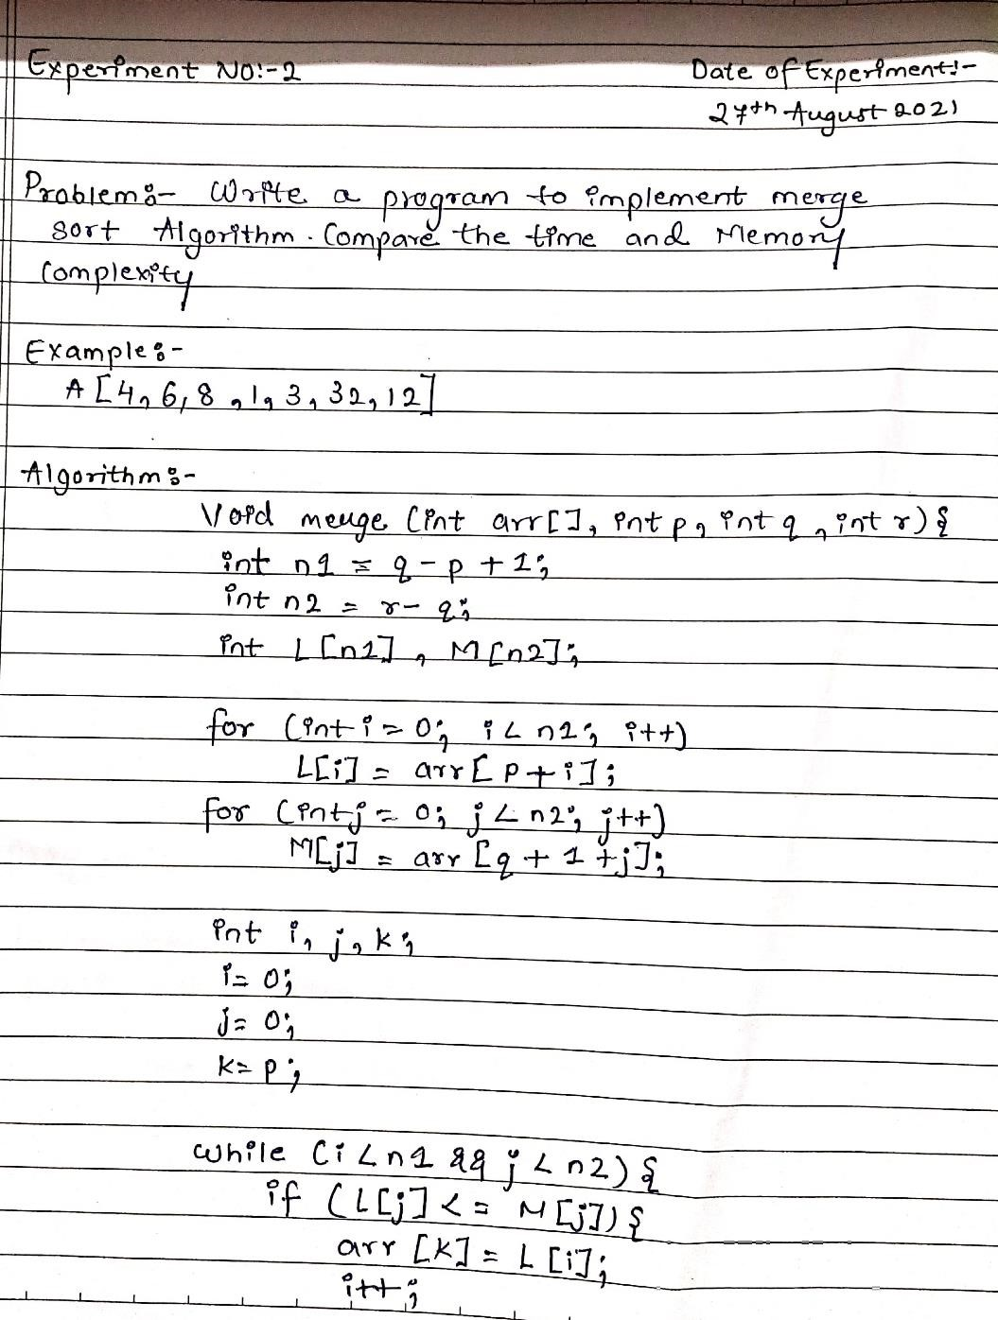

**Fig :**

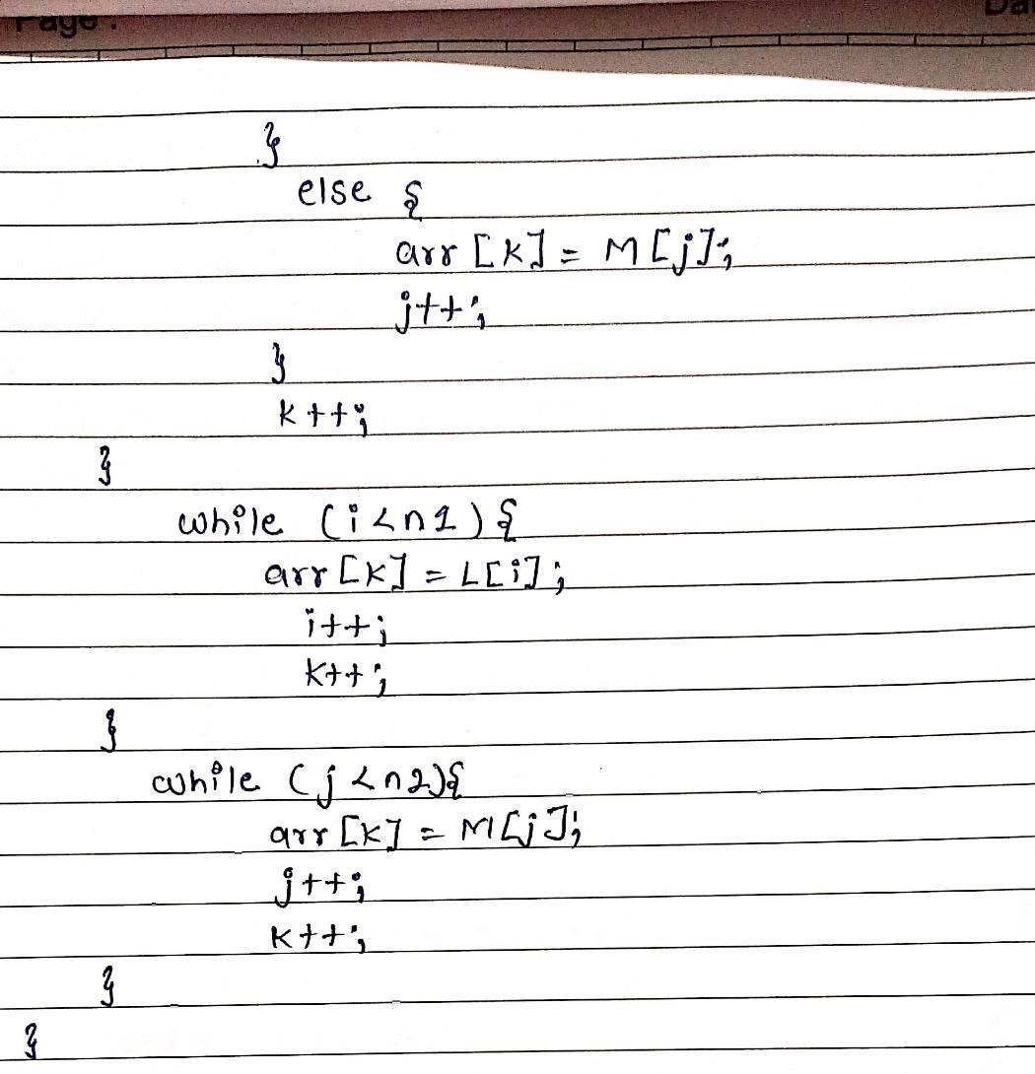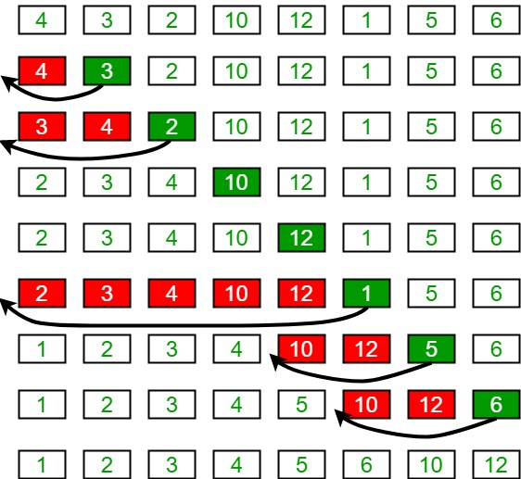

**Program:**

**-**

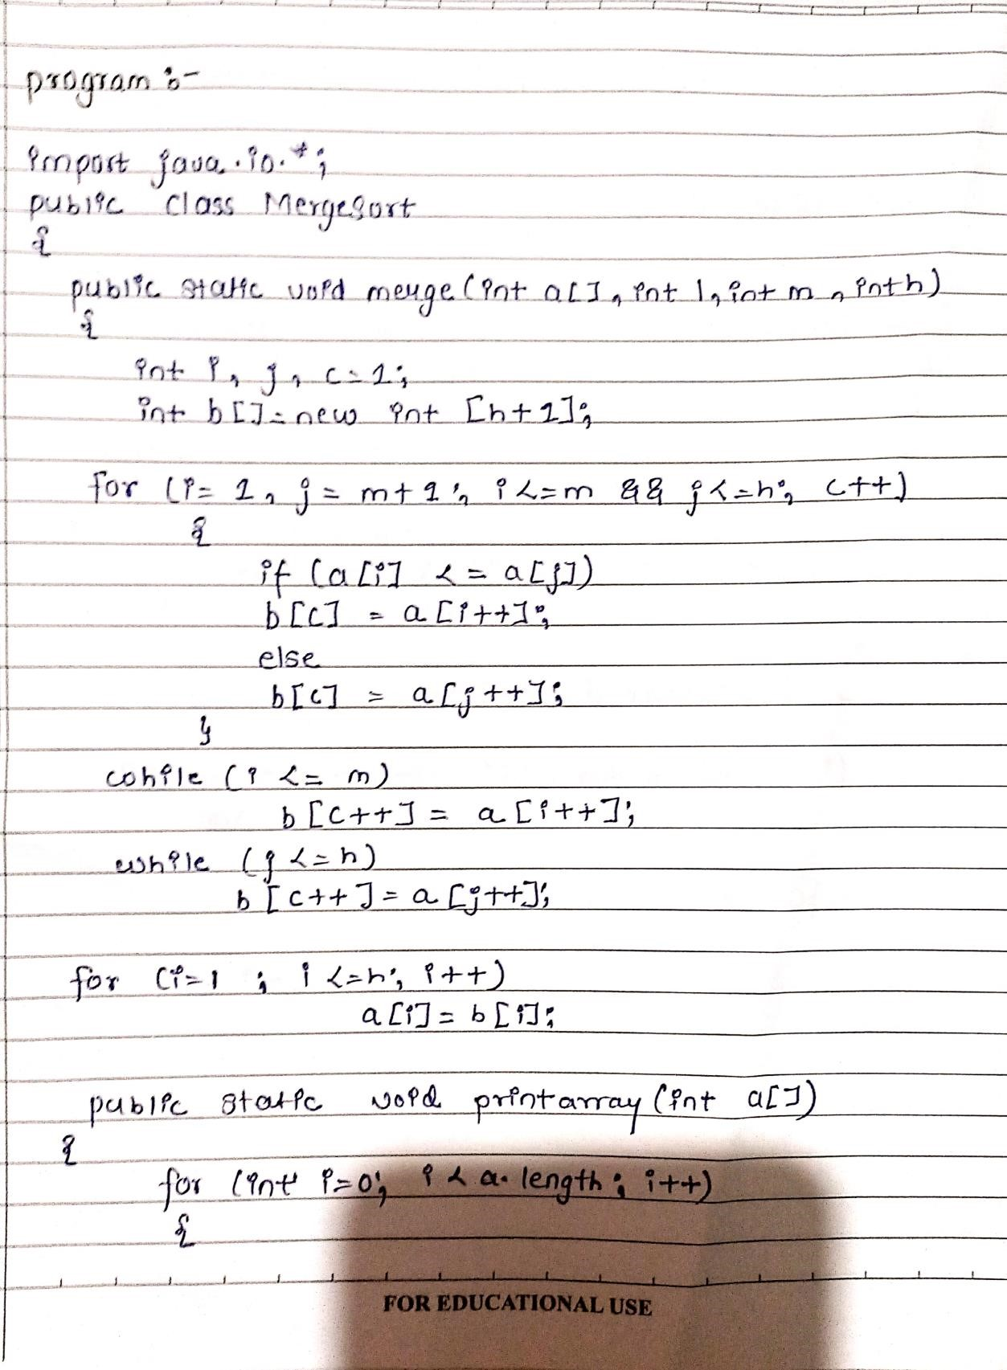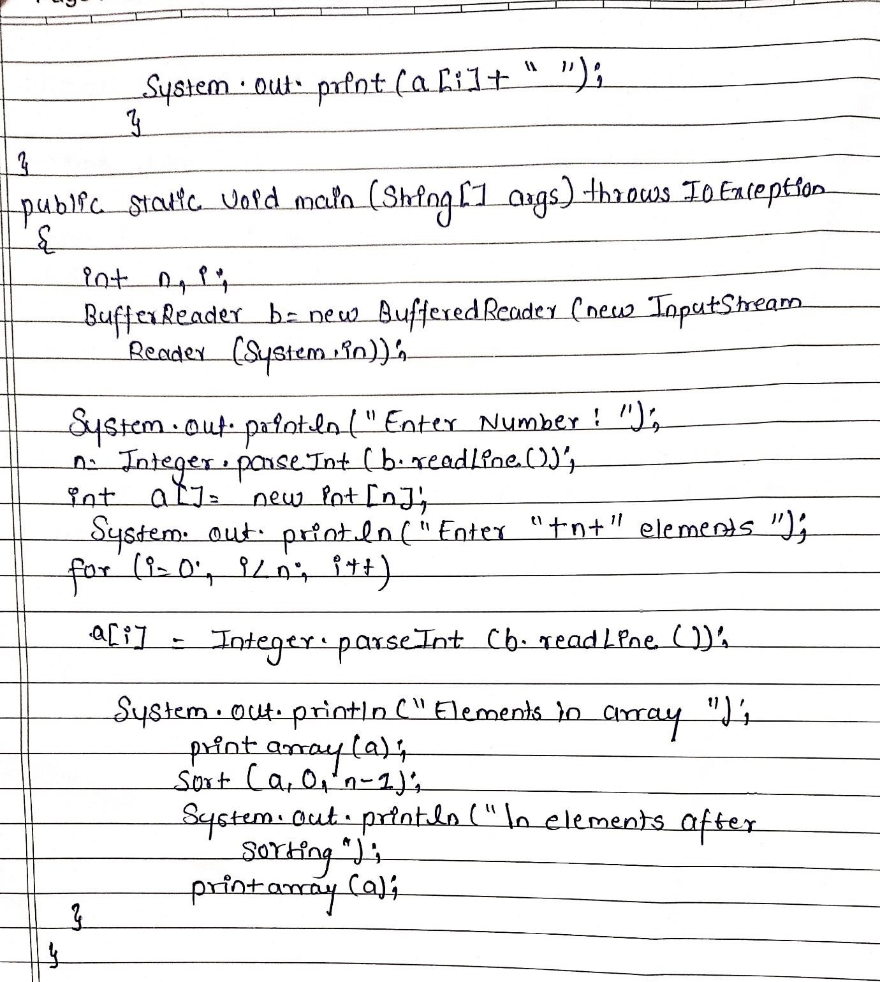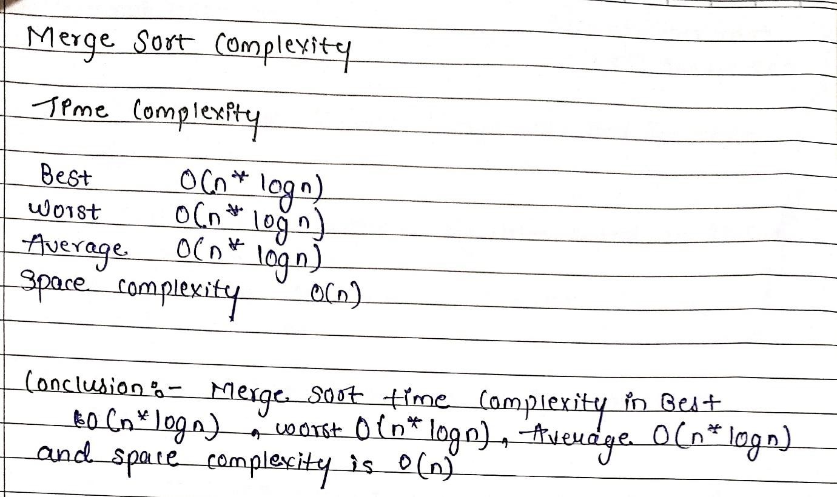

**Practical Implementation of Insertion Sort** :-

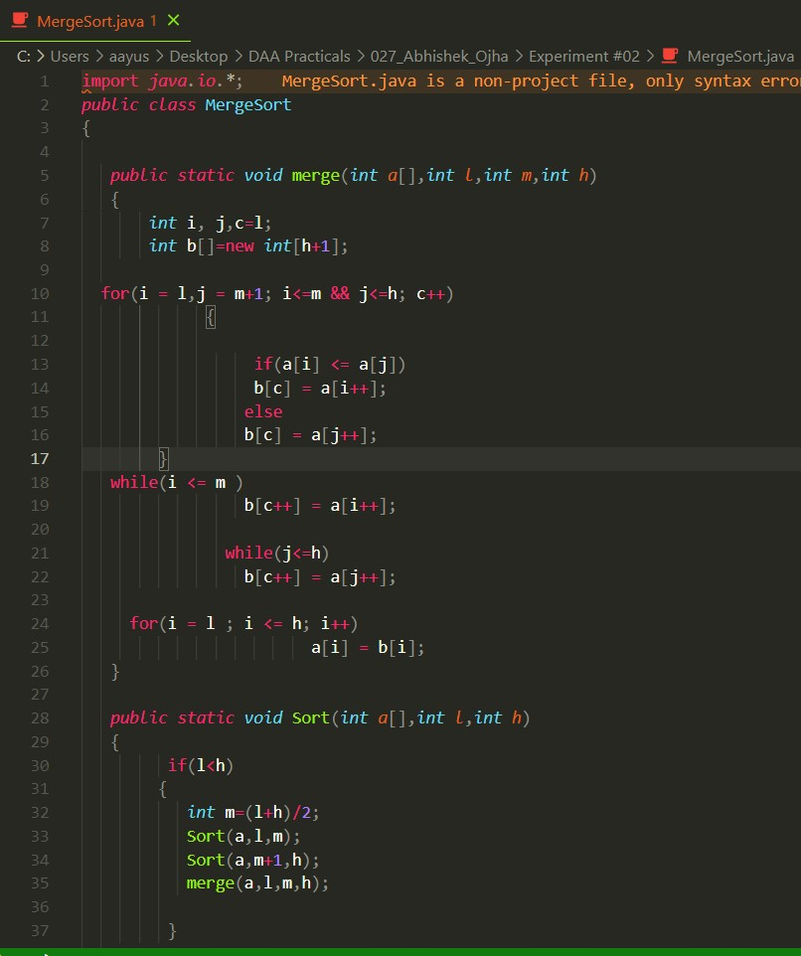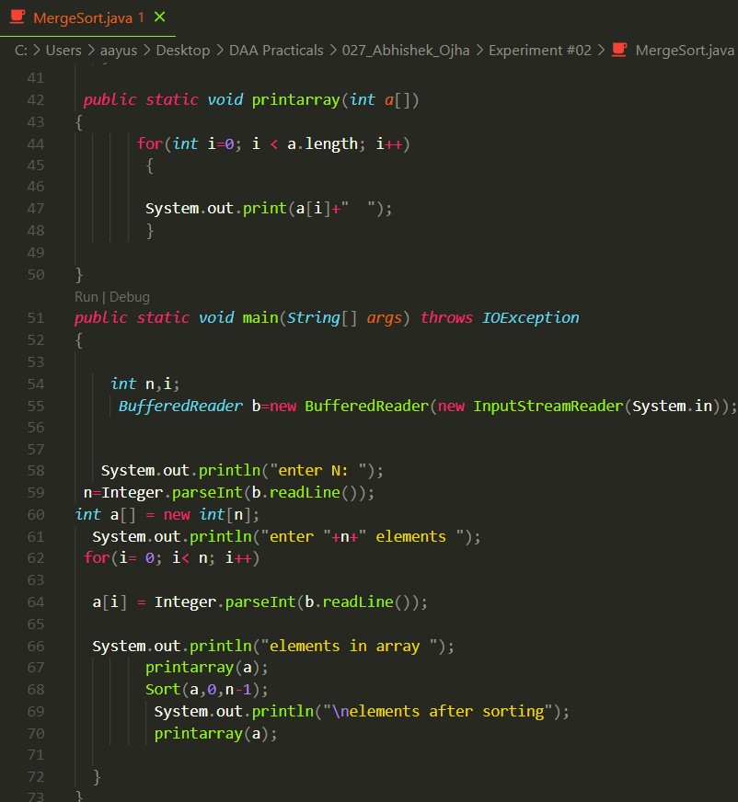

**Output:**

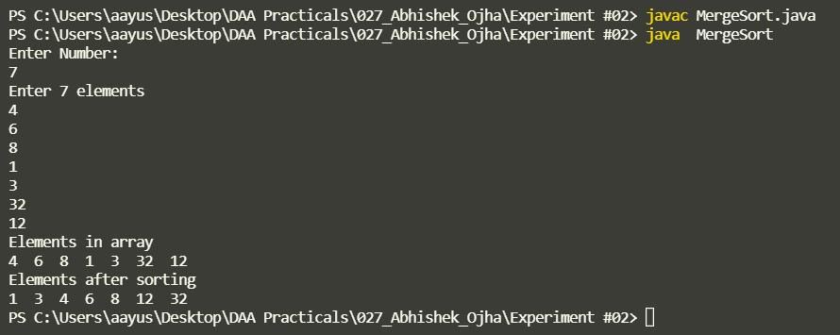

**Conclusion :**

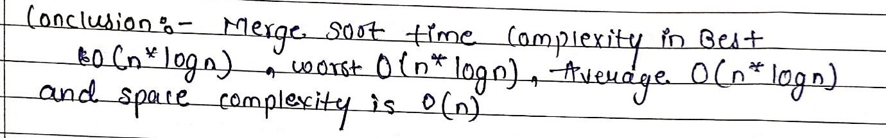

**Experiment No -2B Date of Experiment : 27 August 2021**

**Program :** Difference between Merge Sort and Insertion Sort

